The Petts family came to County Down in 1911 when John Jeremiah Petts took up the position of Kennel Huntsman to the County Down Stag Hounds in Ballynahinch. With him came his wife Annie (nee Finlay) and nine of their ten children. John, aka Jack, came originally from Kent as did his forebears. Until he came to Ireland, he had been a hunt servant to several foxhunts, in Kent, Sussex, Yorkshire and most notably with the Hurworth in County Durham where he met and married Annie in Hurworth-on-Tees. He did not enjoy hunting the ‘carted stag’ and accounts vary as to whether he resigned or was dismissed from the Stag Hounds in 1913. The family then moved to Comber and took residence in no. 2 Castle Lane (later this became no. 18). By then they had an eleventh child and in 1914 their twelfth baby was born; the only one born in Comber. Their eldest son, Alfred William (b 1895, Hurworth-on-Tees), never moved to Comber. He had stayed on in England to train as a Jockey, which he did not enjoy. He subsequently ran away from the stables, lied about his age and joined the army at the beginning of The Great War. He was posted to the Royal Horse Artillery and served most of his war in Mesopotamia. After demobilisation he took up the family occupation of a hunt servant, the fourth generation, with fox hunts in Surrey and Yorkshire.

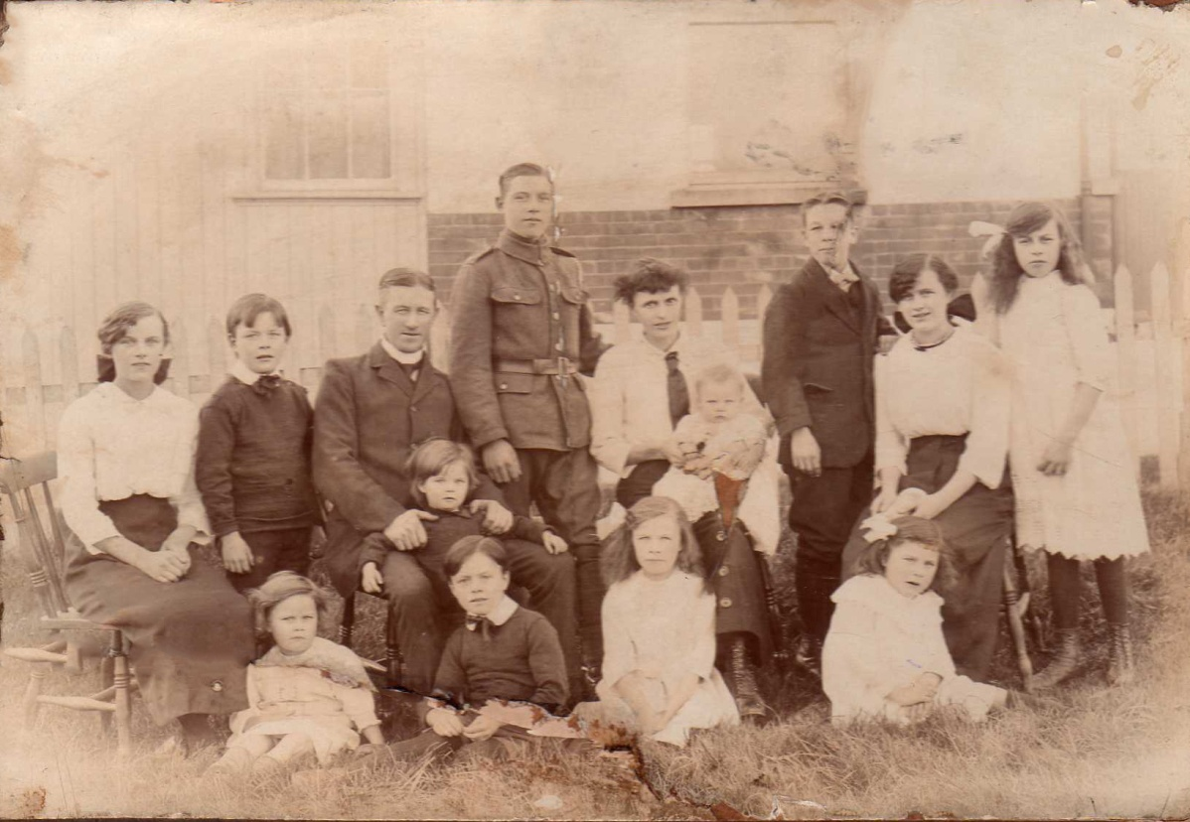
Mary Winifred, Gerrard, John Jeremiah, Alfred, Annie , John Edward, Alice, Ruth
(Winnie) (Jerry) with Nevill with Ritson (Ted)

Freda Neil Idina Jessie

There is only one record of John, Annie and all twelve children being in Comber at the same time. This is a photograph taken on The Green in front of the Cricket Pavilion sometime in early 1915. Alf was in uniform and probably on embarkation leave. The rest of the family settled down and became integrated into Comber life. John Jeremiah also joined up and became a Sergeant in the Royal Veterinary Corps. As a result of injuries to his lungs by poison gas John was given a medical discharge and pension in October 1918. He never hunted again.

Alice Finlay (b 1897) in Hurworth-on-Tees, County Durham) the eldest daughter married Herbie Wishart who worked in Harland and Wolff’s shipyard and they lived in the bungalow that Herbie built at Mount Alexander. They had two sons Walter and Brian. Walter became a Director of Harland and Wolff’s. He played Cricket for North Down as both as an opening batsman and a highly regarded fast bowler and held various senior offices within the Club.

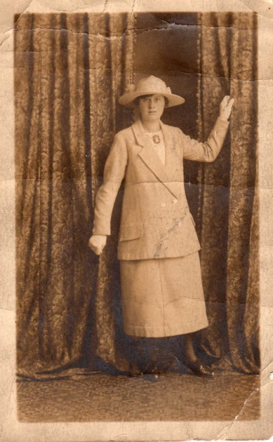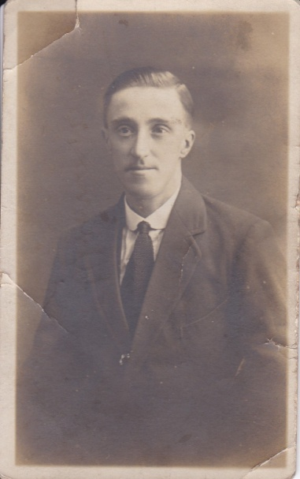

Alice Petts Herbie Wishart

Mary Winifred who was always known as Winnie (b 1898 in Hurworth) married William James Baxter known as Jim. They lived a few doors away from Annie Petts in Castle Lane. Jim played Cricket for North Down and was an International Cricket Umpire. They had three children. Gertrude Winifred – universally known as Lodie as apparently when she was very young her grandfather would always say ‘hello dear’ to her and she replied ‘lodie ‘as she was unable to get her young tongue round the full phrase and it became her nickname. Wilmer worked in Harland and Woolf’s and was a long serving Director of the company. He also played both hockey and cricket for North Down. Jean was the youngest.

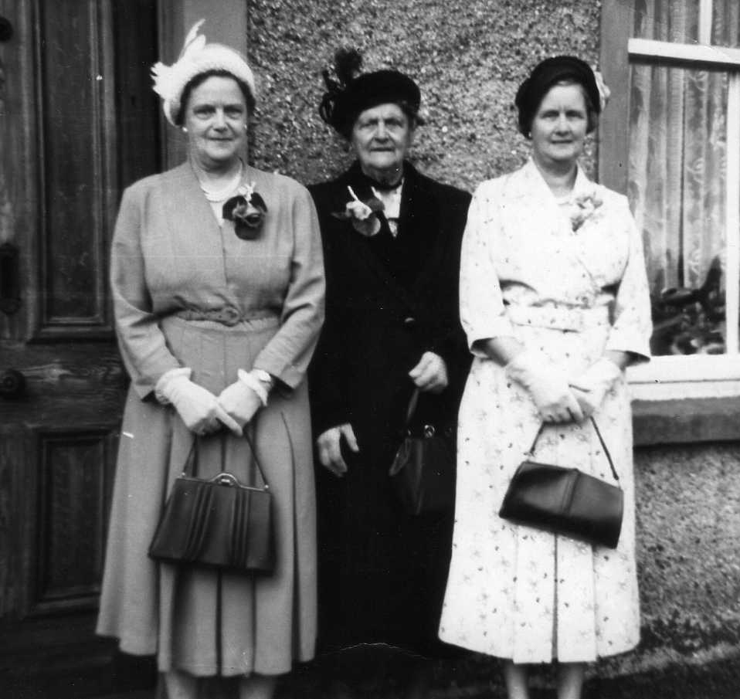

Winnie Baxter, Annie Petts, Alice Wishart

John Edward known as Ted (b 1899 Hurworth) He served his time as an electrician and returned to England in the 1930s, living for the rest of his life in Bexhill-on-Sea where he met and married Evelyn Sinclair. There, as he came from Ireland, he was known as Mick. They had a son William James known as Jim.

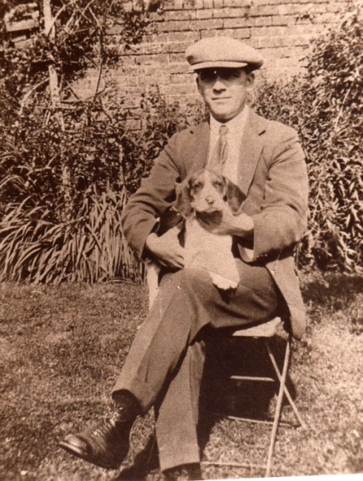

John Edward Petts

Ruth Finlay (b 1901 Hurworth) married James Eldridge in Dover in 1930 but died a year later in Bexhill-on-Sea.

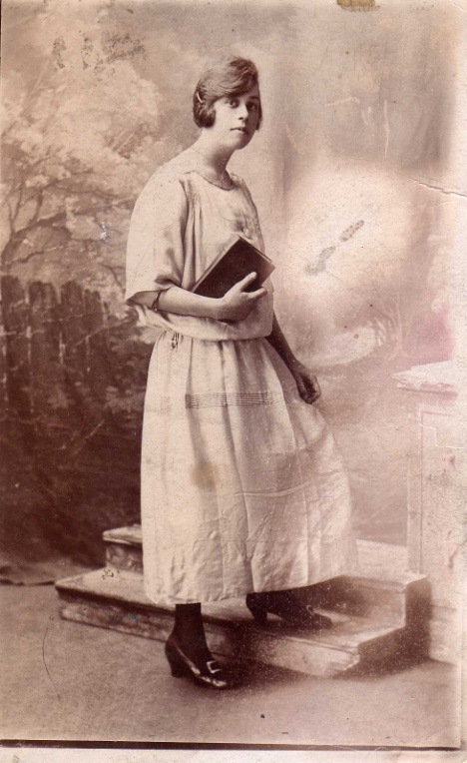

Ruth Finlay James and Ruth Eldridge

Idina known as Ida (b 1904 Hurworth) married William (Willie) Gamble. Willie was very active in the Orange Order and was at one time Deputy County Grand Master. They one son James (Jimmy) who married Eva Dempster.

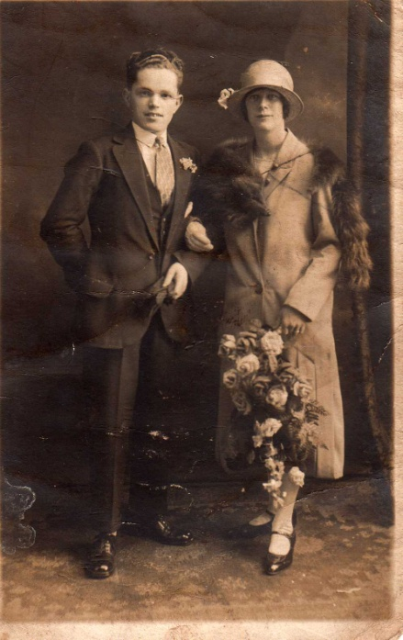

Idina and Willie Gamble

Gerard (b 1905 Hurworth) know as Gerry married Gertrude Geddis. They had three children, John Edward, Gwendoline and daughter known in the familt as ‘Dean’. Gerry and the children moved back to England in the 1930s and lived in Kent and following a divorce he later remarried and had a son Alan. John was a navigator in the RAF and rose to the rank of Squadron Leader. Gwen married and had a large family but I have been unable to trace ‘Dean’

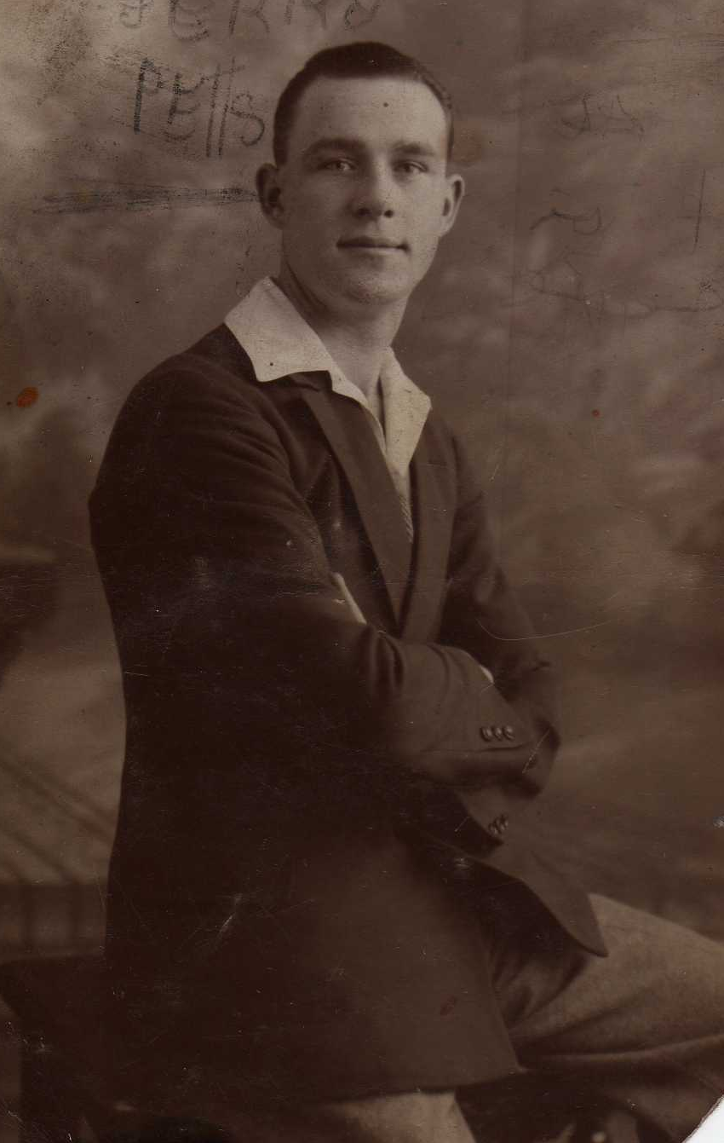

Gerrard Petts

Neil Finlay (b 1906 Danby, North Yorkshire) married Christine Waterson they had one son Neil known in the family as wee Neil. Neil senior worked as chauffer for Willie Andrews. He was and International Cricket Umpire and on occasion stood with his brother-in-law Jim Baxter in Test Matches. He was also a long serving member of the Special Constabulary. Neil and Neil junior were enthusiastic pigeon racers winning the Kings Cup in 1956 with a bird called “Shot Hen’ and many other trophies. Neil Junior died in 2011, he did not marry and thus he was the last Petts in Comber. The Jazz Singer Ottilie Paterson was born in the house in which Neil and his family lived until Neil jnr. died and it now bears a Blue Plaque recording this.

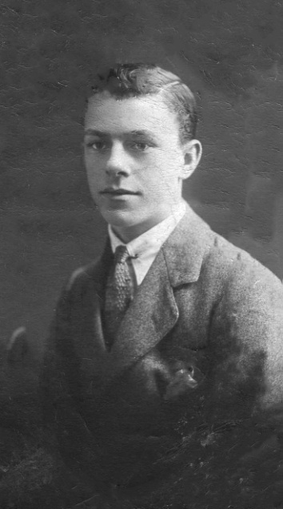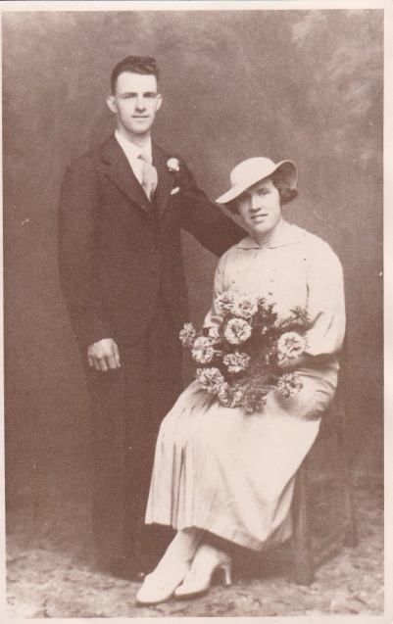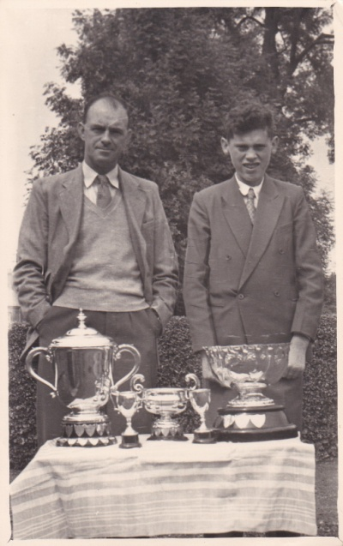

Neil Finlay Petts senior Neil and Christine Petts Neil Petts senior and junior
with pigeon racing trophies

Jessie Finlay (b 1909 Otford Kent) married Sam McKeag they had one son Jack

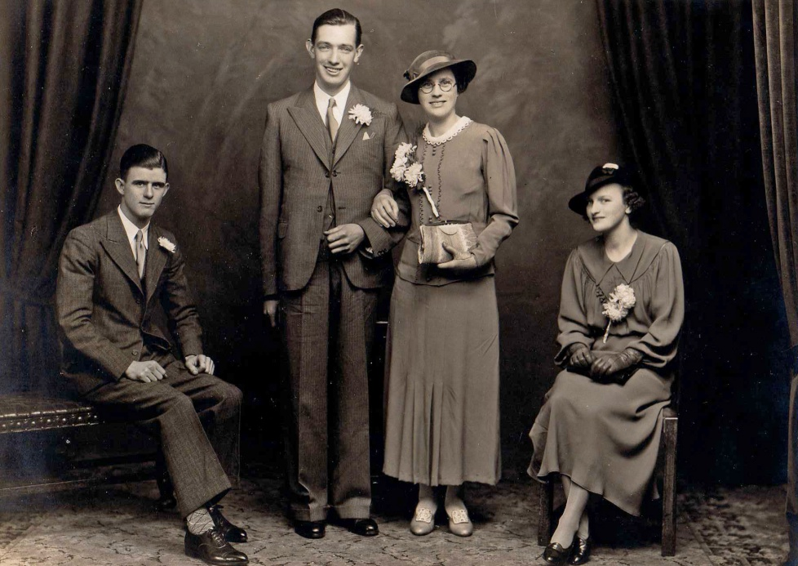

Neville Petts Sam and Jessie McKeag ‘Lodie’
Freda Finlay (b 1910 Otford Kent) married James Wright they had one daughter Joy. In the early 1930’s Freda died of Miliary Tuberculosis. Apparently, there was an outbreak TB in what was called the ‘stitching’ a factory in Castle Lane

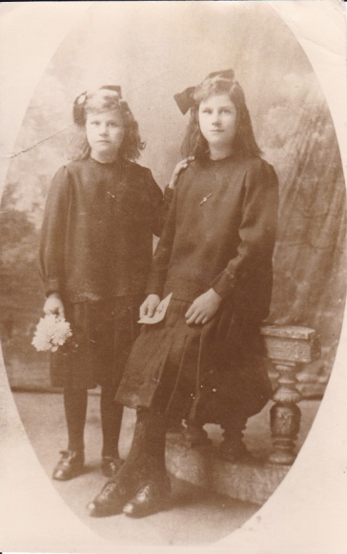

Freda and Jessie Petts

Nevill (b 1912 Ballynahinch, Co. Down) the first Irish member of the family. He married Irene Edgar who was originally from Antrim Town. They had a son David and daughter Elizabeth Mary. Originally, he was named Nevill but he added he ‘e’ later and became Neville. He served his time in the Harland and Wolff’s as miller turner, then went to sea. On his return was unemployed and got a job in 1937 with Vickers Armstrong in Crayford, Kent. After the WW2 he retrained as a nurse first in mental health and then in general nursing. In 1959 he returned to Comber with the family and took up a senior nursing post in Newtownards hospital but they returned to Kent in 1962. Neville was a prominent member of both North Down Cricket and Hockey Clubs. He was a member of the Cricket team that did the league and cup ‘double’ in 1936. In 1999 when the club won the senior league for the first time since 1936, he was the only member of that team still alive and was the guest of honour and presented the prizes at the club dinner that year. He died a few weeks later.

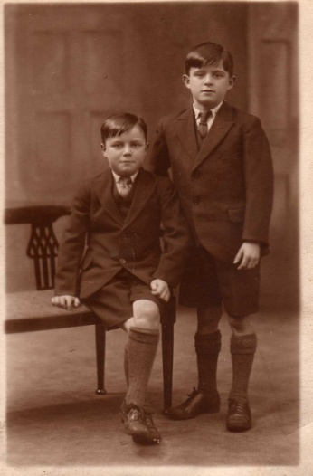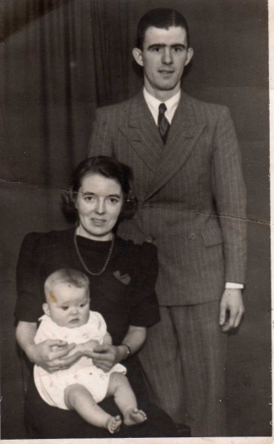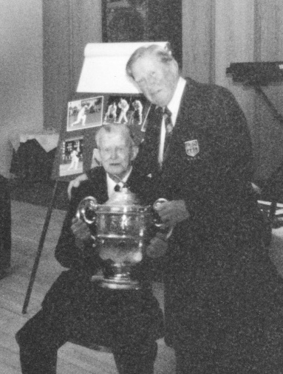

Ritson and Neville Petts Neville Petts Neville, Irene and David Neville and Walter Wishart
And the Senior League Cup

Ritson Finlay (b 1914 Comber, Co. Down) he joined the RAF in the 1930s, passing out top of his intake and was awarded the stick of honour, which sadly is no longer in the possession of the family. He became a Leading Aircraftsman and was posted to Singapore where died in a flying accident in 1939. He death is recorded war on memorials in Comber, Singapore and in St Clement Danes, the RAF Church, in London

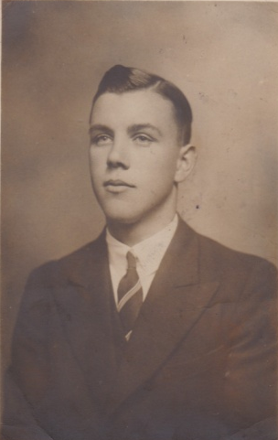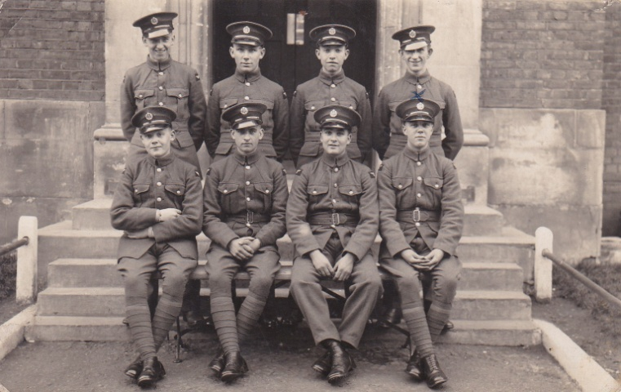

Ritson Finlay Petts Ritson Petts front row right

Epilogue

This is the story of how family came from outside the village and over the next century became integrated in to its life and activities then faded from view. They took an active part in the social, sporting and church life of Comber. A search of local newspapers of the 1920’s and 30’s reveals report their participation in Church Socials and plays at the Unitarian Church, Gerry playing drums in in small band for dances in the Masonic Hall as well as the exploits of Neville and his brothers on the Cricket and Hockey fields.
But gradually the boys left the village only one of Jack and Annie’s sons, Neil, remained and settled in Comber, the others, in the post-depression years, left to find employment in England. Neil had a son but ‘wee’ Neil never married and when he died in 2011 the surname died in Comber as well. The girls married local boys and some of their descendants remain but of course have different surnames and a different heritage, their English roots long forgotten. Never-the-less Petts’ left their mark although it is much less visible now.

